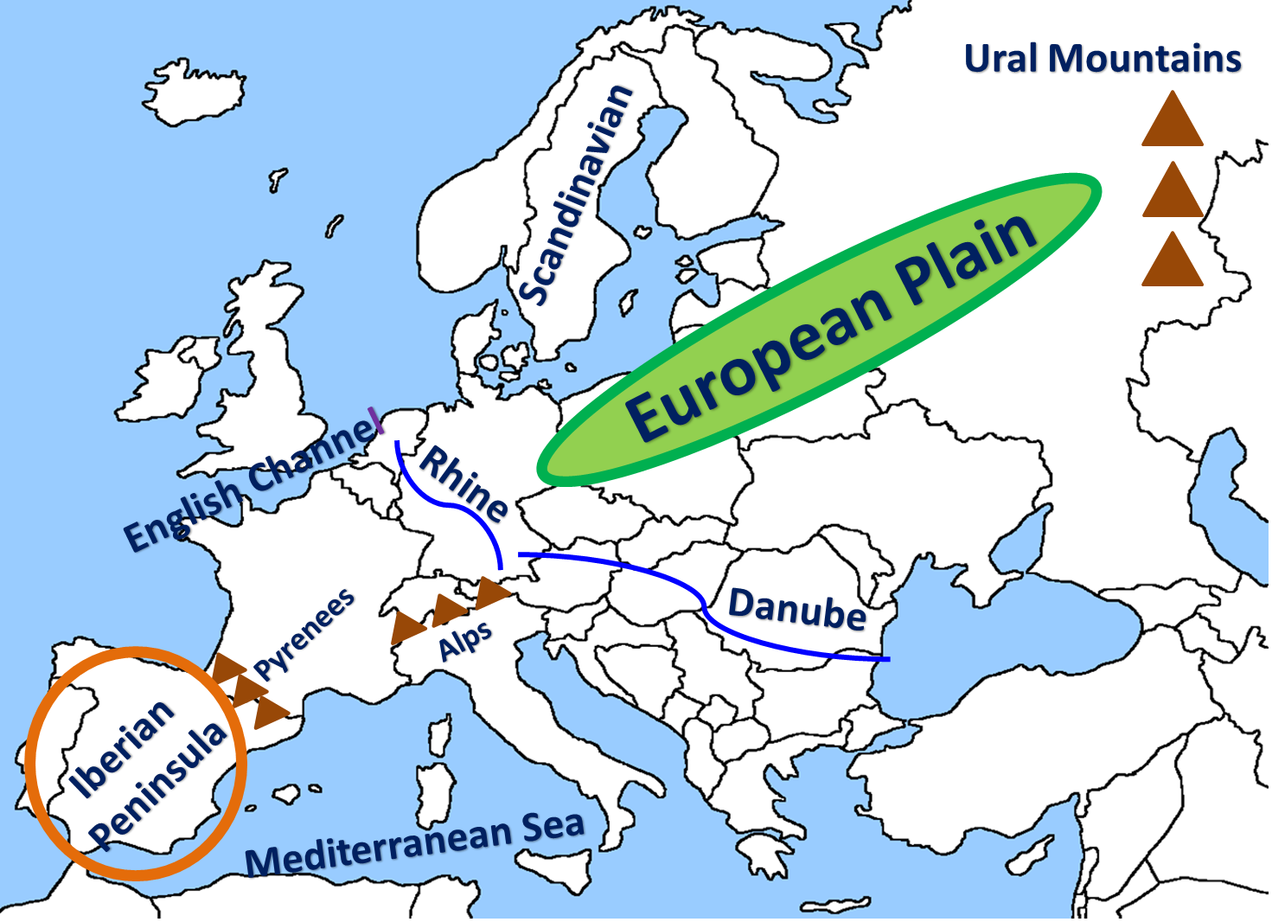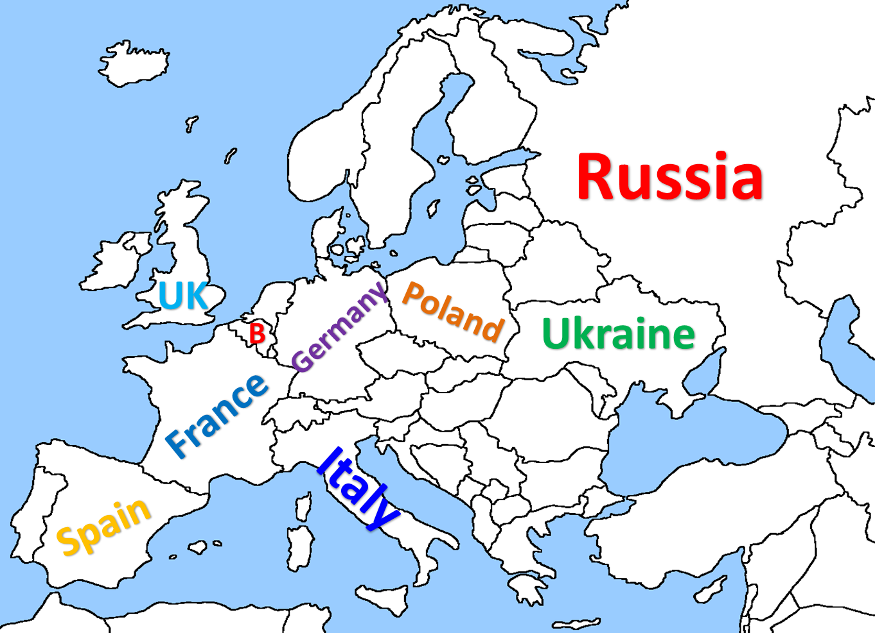

Parent Signature:________________________________________________________________

**By signing this, you acknowledge that you witnessed and/or helped your child study for his or her geography quiz.