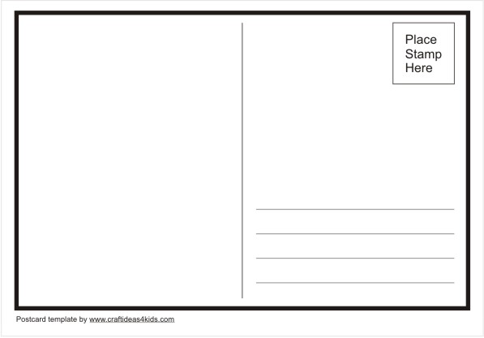
BACK:

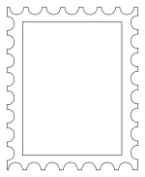
STAMP

FRONT:
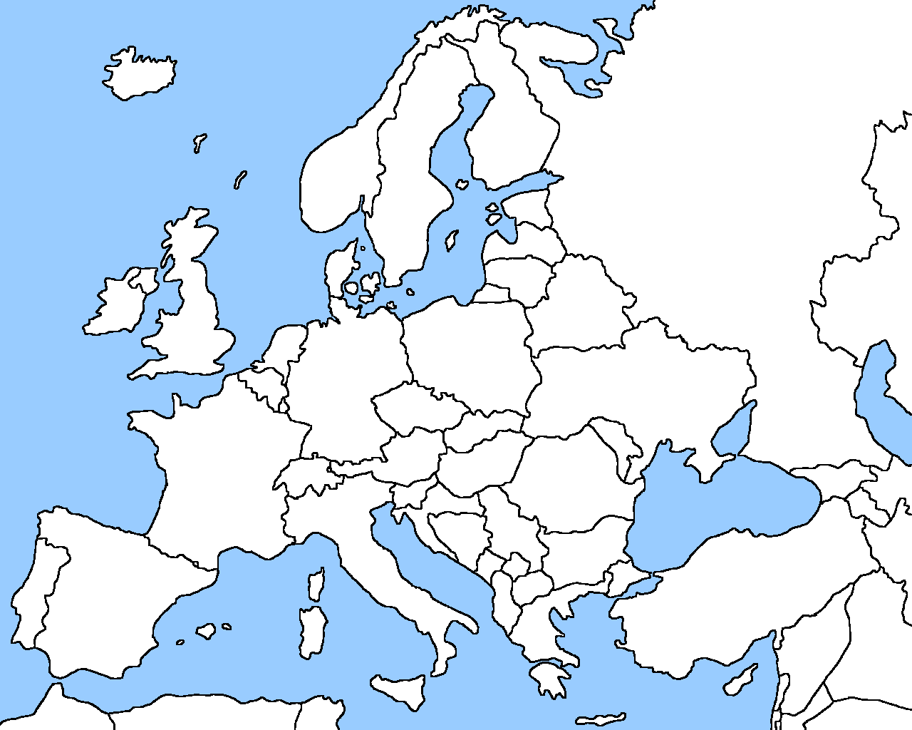
EUROPE

You are currently hiking across Europe, visiting various countries and physical features. You want to keep your family and friends updated on all of the cool sites you see but you don’t have Internet access and can’t make phone calls, send text messages or post on Facebook. You can however send a postcard!
Use the following instructions to design and send your postcard:
- Label the front of your post card with places you have “visited”:
- Choose any three (3) countries: Belgium, France, Germany, Italy, Poland, Russia, Spain, Ukraine, United Kingdom
- Choose any three (3) physical features: Danube River, Rhine River, English Channel, Mediterranean Sea, European Plain, the Alps, Pyrenees, Ural Mountains, Iberian Peninsula, Scandinavian Peninsula
- Use pages A14 and A15 to label map
- On the back of the post card write a short paragraph detailing your route through Europe. Be sure to use cardinal and intermediate directions
- Example: “Dear mom, I started my travels in the United Kingdom then sailed south across the English Channel to France. While in France I went southwest to visit the Pyrenees Mountains. Lastly, I traveled to Spain and visited the beautiful beaches of the Mediterranean Sea. See you soon! Love, Vanessa”
- Address your post card to a friend or family member. It can be a fake address if you choose.
- Design a postage stamp using a flag of a country you have visited. Use pages 282-285.
- Lastly, cut out the post cards and glue the front and back together. Also cut out the postage stamp and glue it to the designated area.

